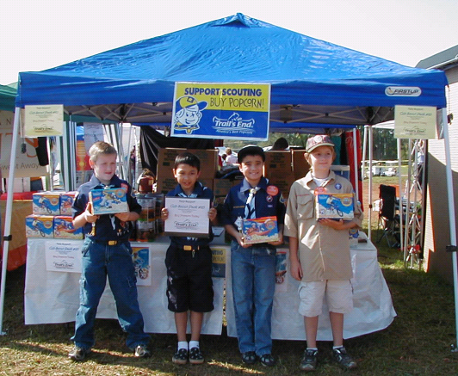
Aaron Correll, Christian Watts, Joe Zimmerman, and Andrew Smith
at Denver Days
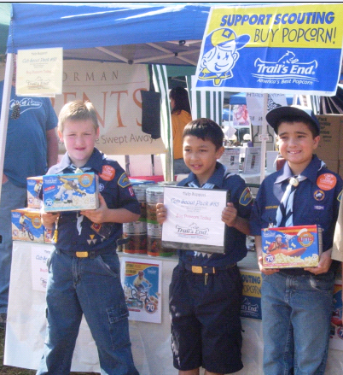
Aaron Correll, Christian Watts, & Joe Zimmerman
at Denver Days

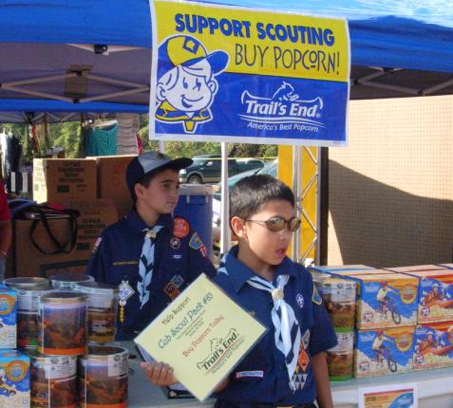
Christian Watts and Joe Zimmerman at Denver Days

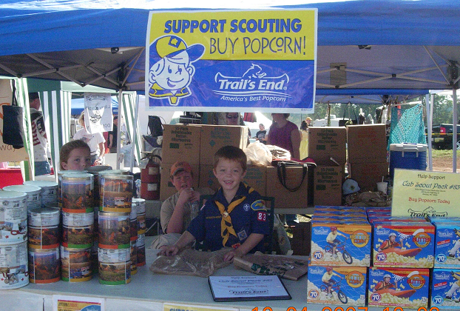
Ben Simpson at Denver Days

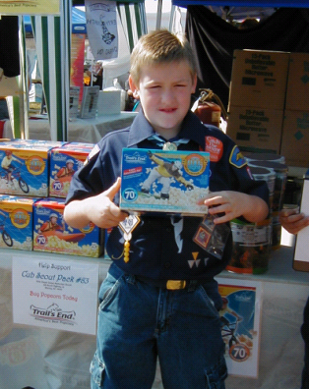
Aaron Correll at Denver Days

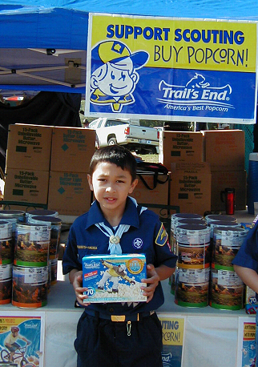
Christian Watts at Denver Days
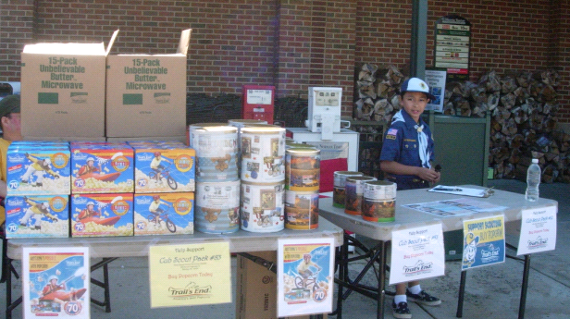
Christian Watts at Harris Teeter

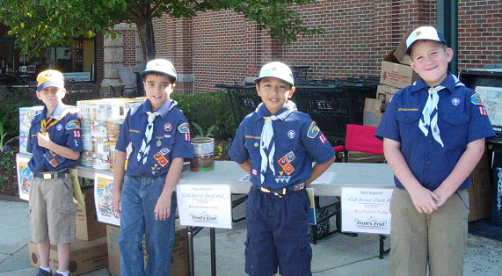
Hunter Blackburn, Joe Zimmerman, Christian Watts, and Austin Blackburn
at Harris Teeter

